LH8800 Ventilator

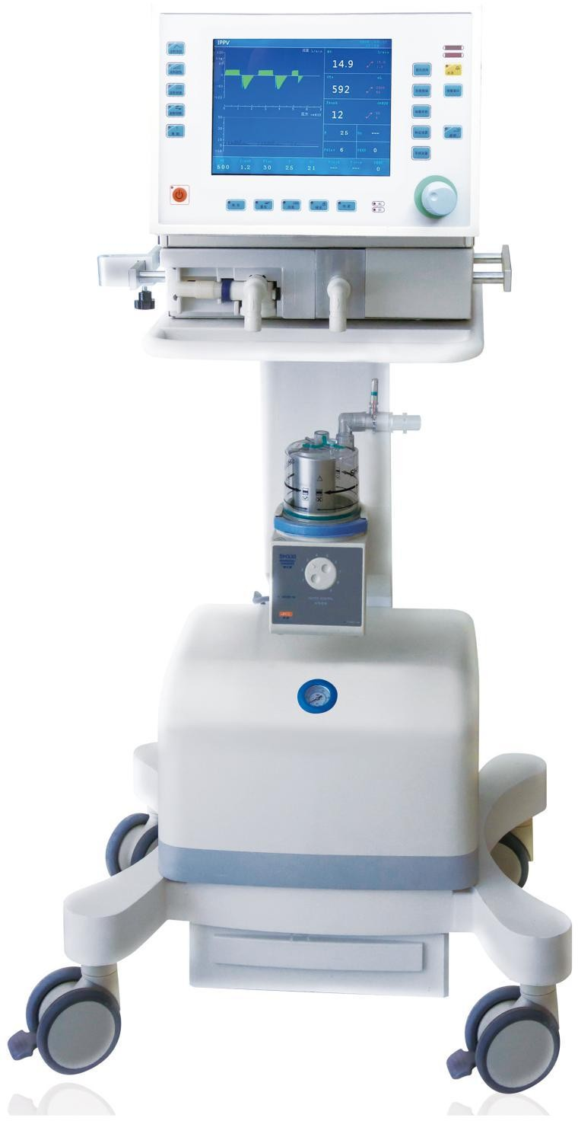

specific

Model | LH8800
Ddiplay | 10.4”LCD screen
Ventilation Mode | VCV/IPPV、PCV、SIMV、PSV、CPAP、BIPAP、SIGH、PEEP
Gas Source | O₂: 280Kpa-500Kpa
 | Air:280Kpa-500Kpa
Power Source | AC：100V-240V 50/60Hz
Features | - Gas - Electricity separation design ensures safe operation;  - Wide application to adults, children;  - Exhalation valve can be disassembled and disinfected, which avoids cross-infection;  - Seamless switching of invasive and non-invasive ventilation mode;  - High integrated modular design of the gas circuit greatly reduces gas leakage , gas loss of system dead space and system compliance and responds rapidly;  - Proportional valve with high speed and high precision sends air quickly and accurately, which improves the man-machine synchronization, reduces the consumption of additional respiratory power, provides patients with comfortable excellent breathing;  - Intelligent identification of off tube, blocking and other conditions ensures the safety of patients;  - Optional: humidifier, medical air compressor.
Tidal Volume | 20ml～2000ml
Volume/min | ≥18 L/min
Breath Time | 0.3-6s
Pressure control | 1—50cmH2O
I:E | 10:1-1:10
Breathing Rate | 0.5-100Times/min
Inspiratory trigger mode | Pressure & Flow
Inspiratory pressure trigger | -20 cmH2O～0 cmH2O
Flow Trigger | 0～20L/min
Maximum safe pressure | ＜125 cmH2O
Inspiratory rise time | 0.1—2.0s
Sign Pressure | 0～25 cmH2O
Pressure Range | 10～60 cmH2O
PEEP | 0-25cmH2O
Asphyxiation backup ventilation time | 10-60s
Oxygen adjusting range | 21%-100%
Monitoring Function | VT, MV, FREQ, FiO₂%, Paw, CL , Flow[L/min], Pa[kPa]，waveform
Alarm Function | - Upper and lower airway pressure limit alarm  - Gas pressure shortage alarm  - Upper and lower minute ventilation volume limit alarm  - Upper and lower tidal volume limit alarm  - Respiratory rate alarm  - Oxygen concentration alarm  - Low battery alarm  - Asphyxiation alarm
Battery | Built-in high capacity battery can ensure the machine working continuously not less than 8 hours

